# Session 8 Assignment 3: Transaction in HIVE

To carry out, updates and deletes in hive first we need to set the below properties needs to be set appropriately in ***hive shell***, order-wise to work with transactions in Hive:

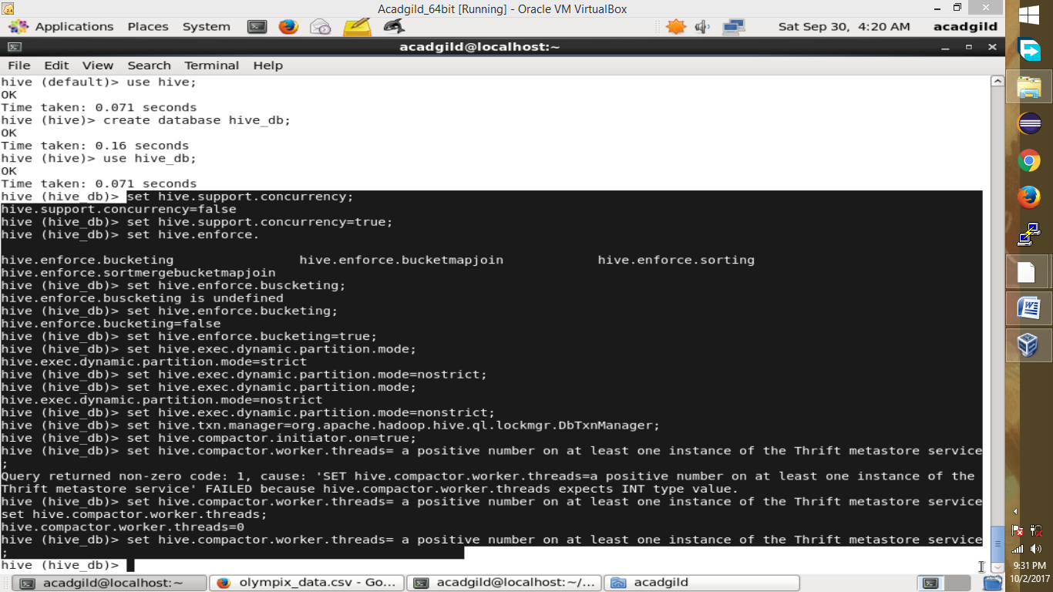

Once, these settings are done, restart the hive server.

Now, open the hive console and create a table.

CREATE TABLE college(clg_id int,clg_name string,clg_loc string)clustered by(clg_id)into5buckets stored asorc TBLPROPERTIES('transactional'='true');

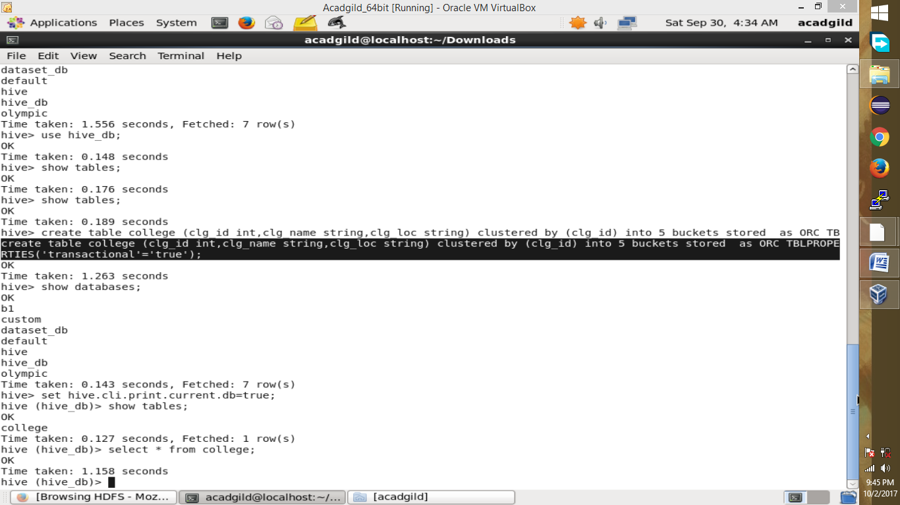

The above syntax will create a table with name ‘*college’*and the columns present in the table are ‘*clg_id, clg_name, clg_loc’. W*e are *bucketing* the table by ‘*clg_id’*and the table format is ‘*orc’,*also we are enabling the transactions in the table by specifying it inside the *TBLPROPERTIES* as *‘transactional’=’true’*

Now, insert data into college table.

INSERT INTO table college values(1,'nec','nlr'),(2,'vit','vlr'),(3,'srm','chen'),(4,'lpu','del'),(5,'stanford','uk'),(6,'JNTUA','atp'),(7,'cambridge','us');

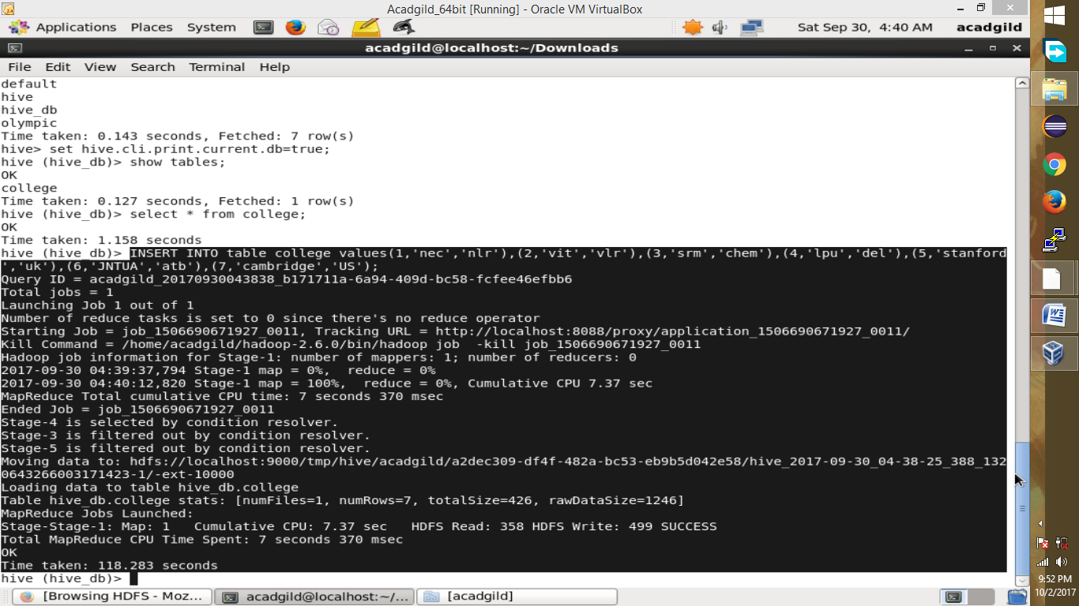

View data in the table.

Select * from college;

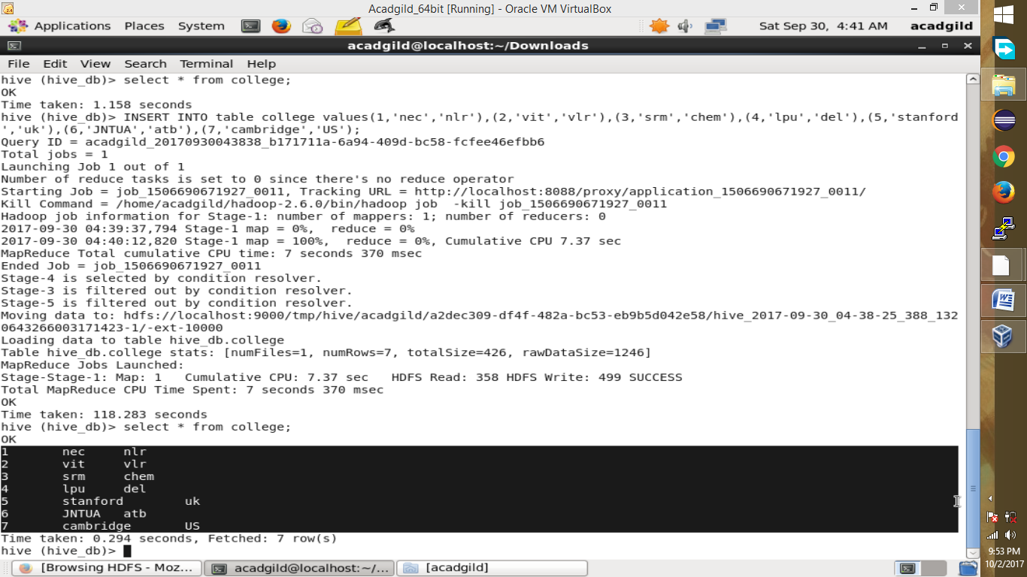

Now if we try to re-insert the same data again, it will be appended to the previous data as shown below:

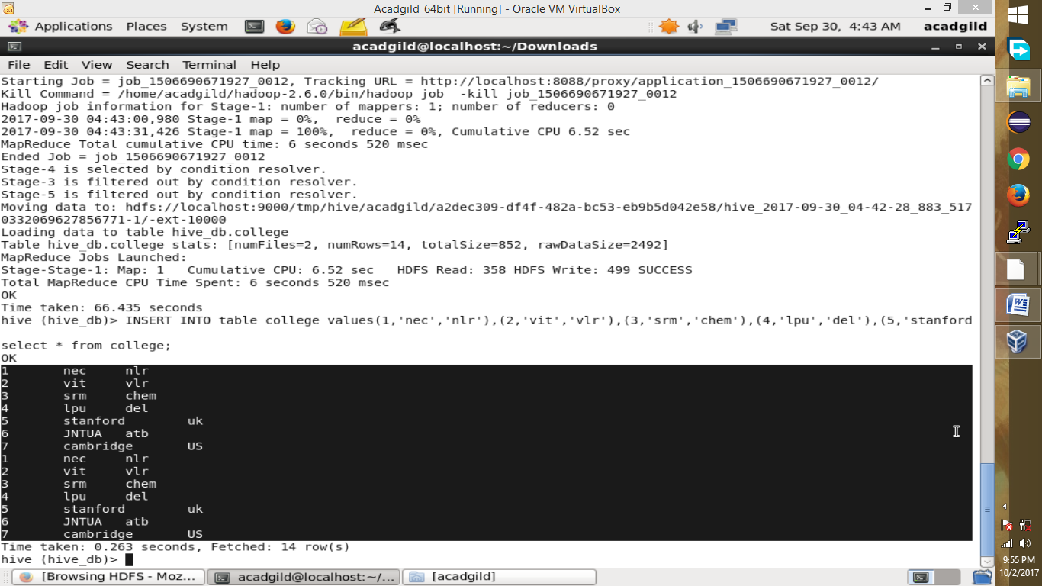

Lets update the college location of college id 1 to xyz (currently it is nlr)

UPDATE college set clg_loc=’XYZ’ where clg_id=1;

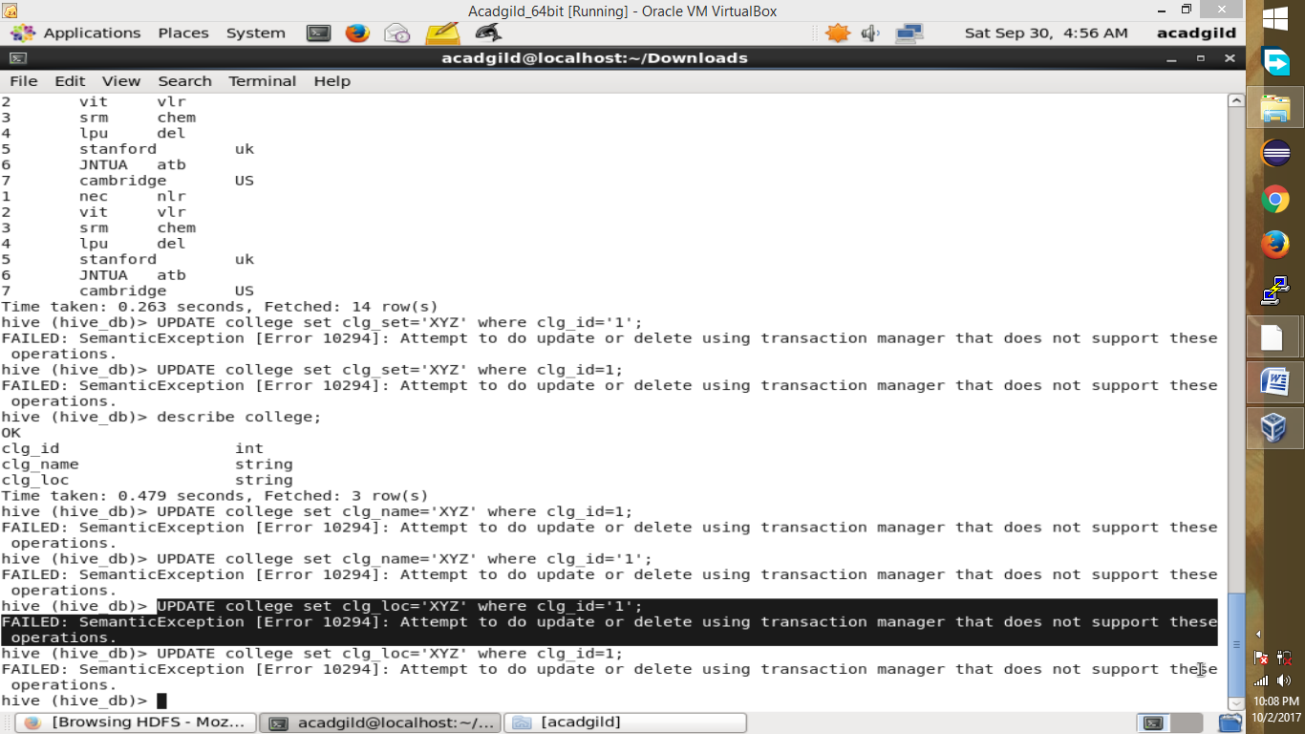

*From the above image, we can see that we have received an error message. This means that the Update command is not supported on the columns that are bucketed*

In this table, we have bucketed the ***‘clg_id’*** column and performing the Update operation on the same column, so we have go the error

Now, again check the data.

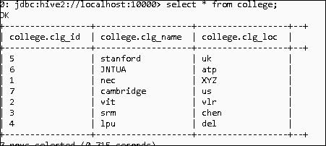

We can see that location has been changed to XYZ for college id 1

Now, lets delete this row from the table.

DELETE from college where clg_id=1

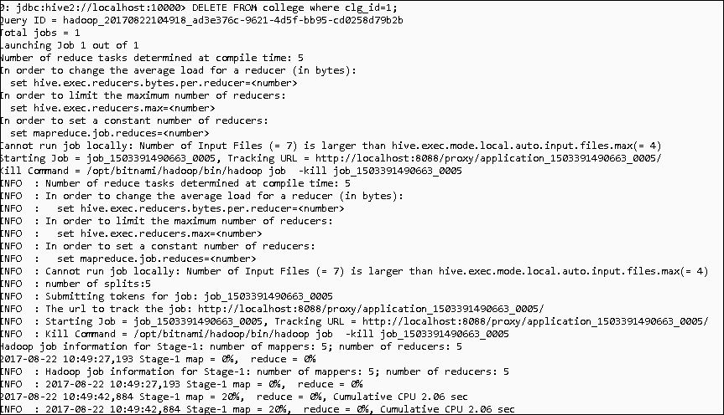

Again, query the table.

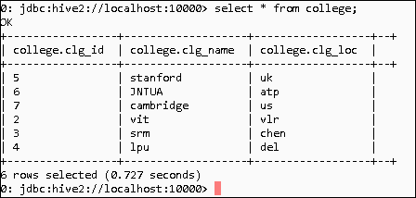

We can see that clg_id =1 is no more present.